Evolution of marketing concept 3
The interconnected pillars supporting data-driven marketing 4
Main methodological approaches in a customer centric key 5
Exploratives analysis 5
Deterministic segmentation 6
RFM algorithm 6
Behavioral segmentation 9
K-means algorithm 10
Hierarchical methods 11
Churn and repurchase models: introduction 12
Churn model 12
Repurchase model 14
Customer Lifetime Value (CLTV) 14
Traditional approach of CLTV 15
Predictive approach Machine Learning 15
Econometric models 16
Customer Satisfaction 17
BRS (Brand Recommendation Score) index 17
Customer Satisfaction - Traditional approach 18
Linear regression model 18
Customer Satisfaction - Innovative approach 19
Neuromarketing & Artificial Intelligence 20
Indigo.AI 22
How to model natural language 23
RNN & LSTM 24
Sentence embedding 24
BERT 24
GPT series 24
From GPT-3 to ChatGPT 25
Emerging Abilities 26
Prompting 26
From models to data 26
How to find the optimal prompt 26
Challenges with prompt engineering 26
Impact on society 26
Closed AI 27
New Name repurchase propensity model 28
Churn Propensity Model 29
Algorithms for association rules (product association analysis) - Market Basket Analysis (MBA) 29
Product propensity model 30
Next Basket prediction by RNN 31
Measurement of marketing communications (marketing communication optimization) 32
Main metrics for measurement of marketing activities 33
Target and control group definition 33
A/B testing 33
Attribution Model 34
Marketing Mix Model (MMM) 35
Linear regression model 36
Multiplicative regression model 36
The interaction of all models allows the creation of a data driven customer journey 37

Lesson 1:

- Increase in big data analytics market size
- Increase use of AI in different sectors (travel, constriction, automotive,...)

Data Driven Culture:
- Data denial: a company denies the value of data
- Data indifference: a company collects data, but do not use them in any way
- Data aware: a company collect data but do not use them in decision making business related process
- Data informed: a company uses data to make informed decisions
- Data driven: a company develops a data driven approach based on data in all possible strategic actions. With data driven approach you can:
  - Have a deep knowledge of customers (360’ vision of purchasing habits)
  - Tailor proposition for each client’s segment ⟹ maximize profitability
  - Maximize client’s value, suggesting right product at right moment with the right communication channel and communication mode

Data driven approach: data strategy pyramid
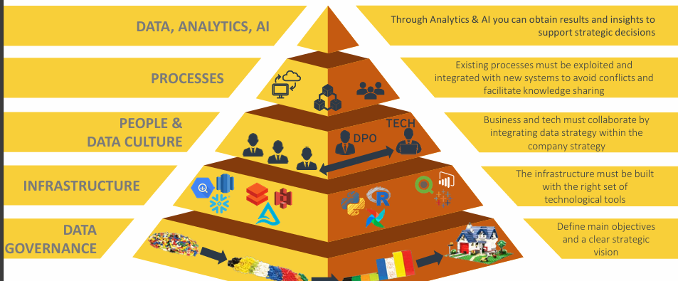

Evolution of marketing concept
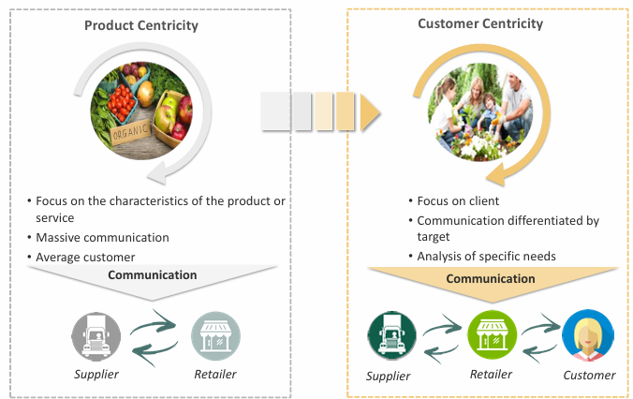

Strategic marketing:
- SWOT analysis of the company
- Study of current and potential customers to identify the reference target of the product/service
- KPI (Key Performance Inq) to assess consistency, efficiency and effectiveness between the strategic plan and the operational plan

Communication with the marketing concept
- Marketing 1.0: communication from the company to the consumer, to large audiences with minimal cost: press, radio and tv.
- Marketing 2.0: two way communication supported by the diffusion of mobile phone and internet: digital tools, telephone surveys, market research and data analysis.
- Marketing 3.0: company focus not only to the consumer but also to create a better world. Focus on Environmental (impact and territory), Social (social initiative with social impact) and Governance (internal aspects of the company and its administration): values ESG.
- Marketing 4.0: aka omnichannel marketing, spread of cloud computing and big data. From 4A model (Aware, Attitude, Act, Act again) to 5A model (Aware, Appeal, Ask, Act, Advocate)
- Marketing 5.0: technological progress, use data-driven marketing and predictive marketing.

The interconnected pillars supporting data-driven marketing
Data-driven marketing approach: define strategic corporate decisions, study the data collected and processed, generate insights with the goal of defining and developing a personalized proposal for the different customer segments to maximize the profitability of the relationship along the entire customer life cycle.

Model development stages
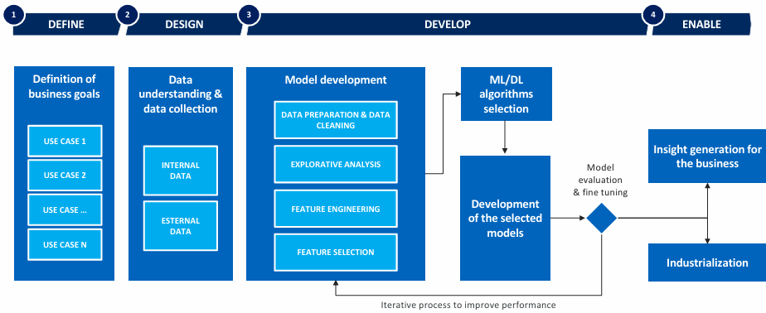
- Define: identify goal of the analysis, tool to be used and type of output to be obtained
- Design: mapping from internal and external data sources and understand the data and the needs they will have to satisfy
- Develop: definition of components of the model
- Enable: summary documentation of main insights

Four fundamental pillars
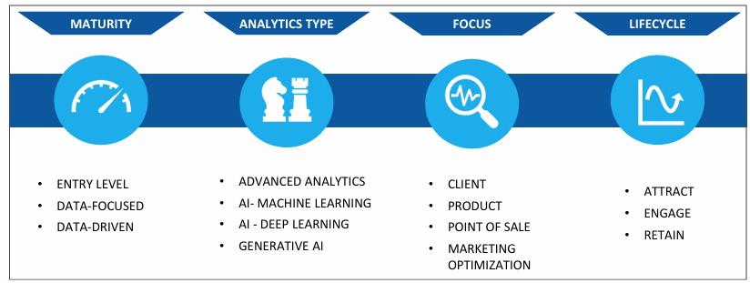

Main methodological approaches in a customer centric key
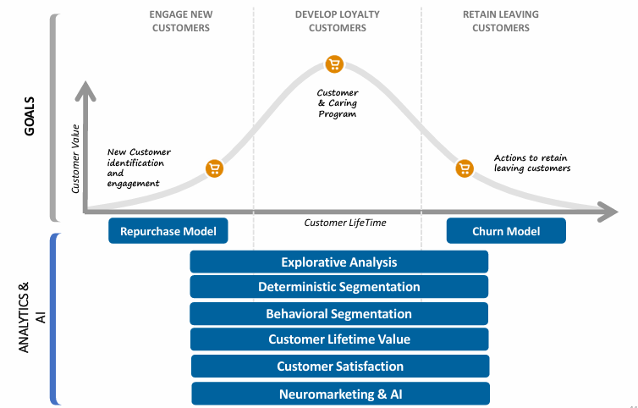

Lesson 2

Exploratives analysis
Loyalty customers vs generic customers

Consider customers with at least one purchase (aka active customers) in 12 months

- One-shooters: make one-time purchase, should be encouraged to make another purchase within 6 months from the last one
- Repeaters: engage with them to maintain a high level of loyalty and identify tailored product proposals

Repurchase curve

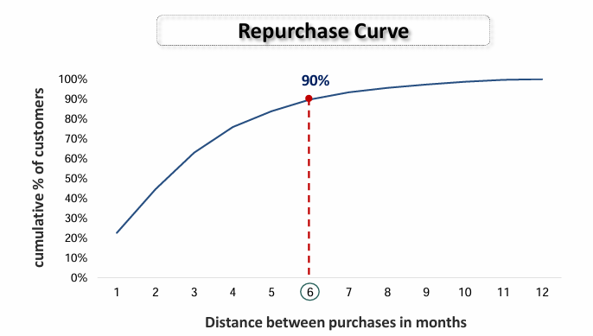
- About 90% of repeaters repurchase within 6 months

Probability of return
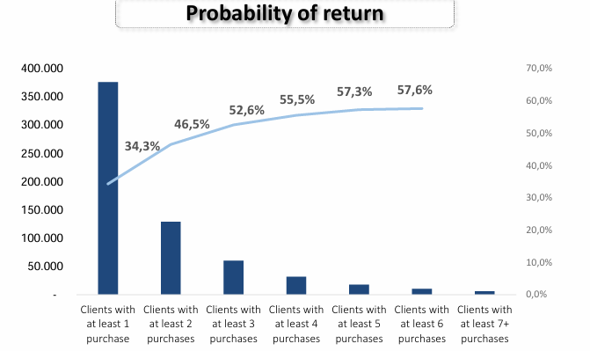
- Probability of return is 34.3% for first time customers ⟹ 65.7% after first purchase never come back a second time
- Increase number of repurchase ⟹ increase probability of return

Deterministic segmentation

RFM algorithm
- Recency (R): time since the last purchase
- Frequency (F): number of purchases made in a specific period of time
- Monetary (M): amount spent in a specific period of time

Goal: identify customer segments to propose to specific marketing actions

Methodological approach
- Define time period [T0 - T1]
- Verify the distribution of the variables to define the number of optimal categories into which divide the three dimension identified (R,F,M)
- Verify the segments that are smaller and/or not very marketing actionable (to remove them)
- Create final segments (like diamond, gold, …)
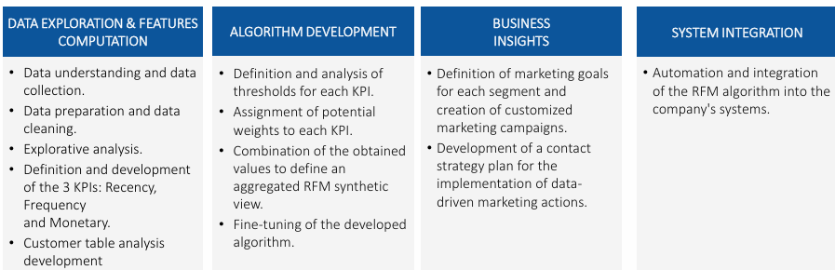

1 - Definition of analysis of time frame
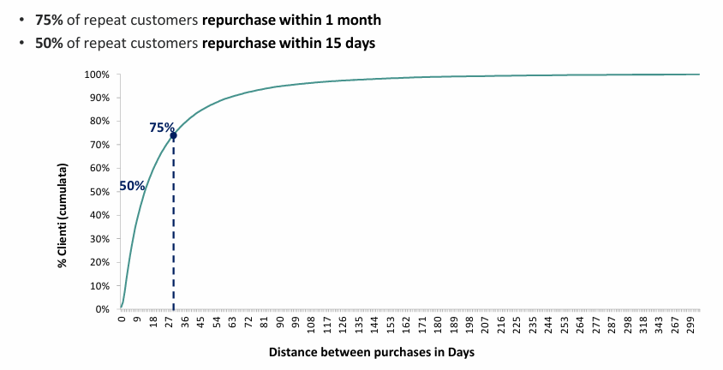

2 - Definition of Recency and Frequency threshold
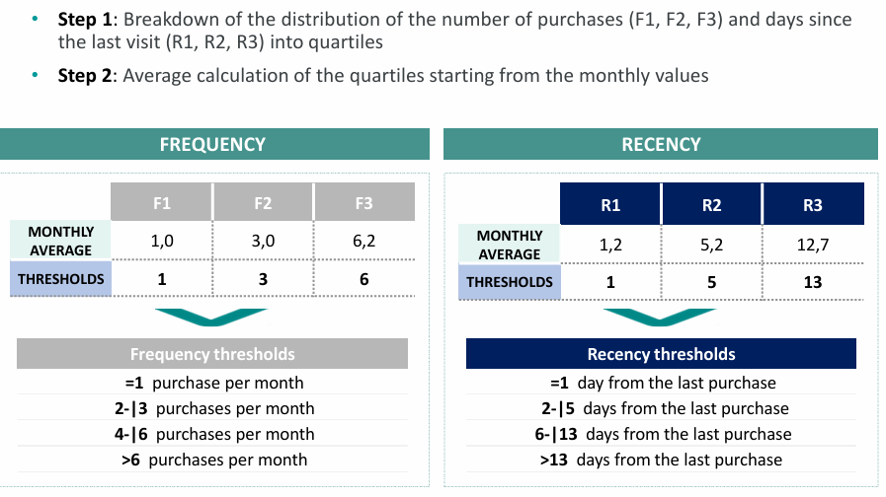

3 - Intersection of Recency and Frequency (R*F)
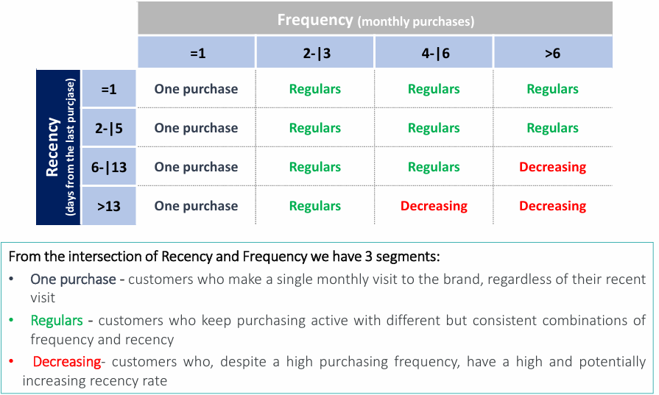
- One purchase: frequency = 1 (1 purchase in a specific period of time). It does not dependent on recency (time since last purchase)
- Regular: keeping buy but different combination of frequency and recency
- Decreasing: buy a lot (high frequency) but visit the store rarely (high recency)

4 - Definition of monetary thresholds

- Step 1: breakdown of the monthly distribution of total amount into tertiles (M1, M2)
- Step 2: average calculation of the tertiles starting from 12 month values
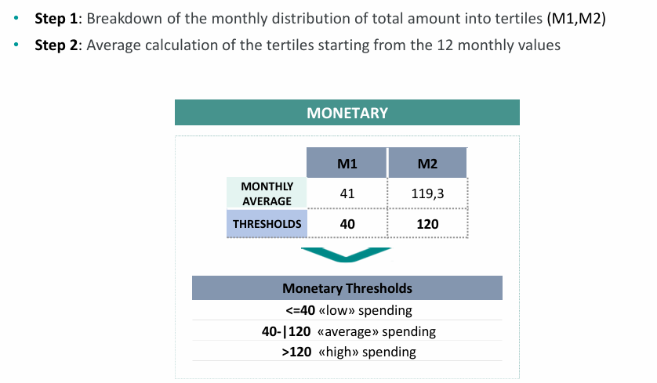

5 - Intersection of segment R*F e monetary
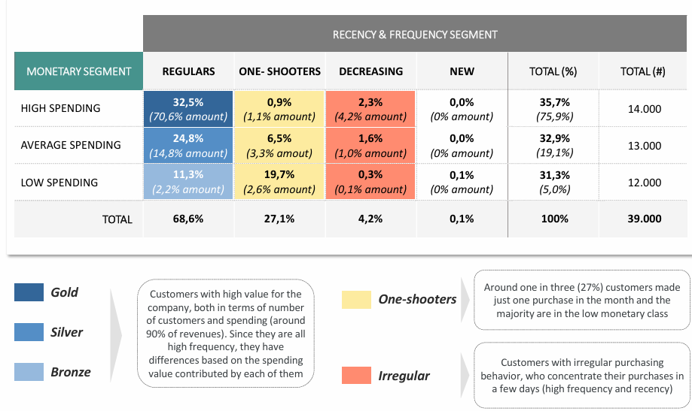

6 - Identification of final segments and marketing actions
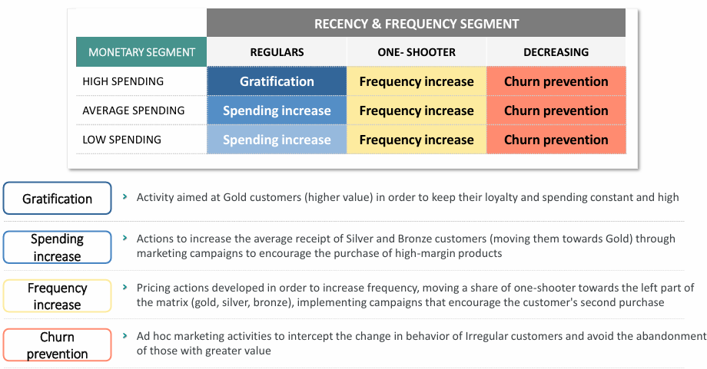

Benefits of RFM
- A priori choice of the dimensions on which to develop the analysis
- Easy interpretation of the segments obtained
- Model useful for entry level companies
- Obtain strategic insights on the customer base
- Develop of tailor made marketing actions
- Timely intervention on customers migration to a lower value segment form T0 to T1

Limitations of RFM
- The use of limited number of variables penalizes the result compared to more advanced analytics models
- RFM are often correlated with each other, generate an overlapping effect during segment construction
- Not allow to natively obtain a single summary indicator (score)

Behavioral segmentation
Cluster analysis: set of all the algorithms that divide observations into subgroups (clusters) in such a way that all observations within each cluster are similar to each other, but massively heterogeneous from the observations in the other subgroups. Divide customers into clusters to better understand the characteristics and needs of each group and to be able to convey tailor made marketing activities
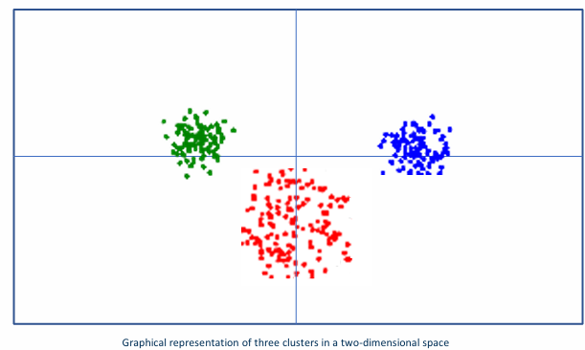

Methods for cluster construction
- Partition methods: subdivide the set of observations into a group of predetermined number of non-empty subgroups
- Hierarchical methods: define a hierarchy within the subgroups using a tree structure and increasing similarity threshold
- Other methods: grid method, density based methods, …

Similarity measure
Assume to work with a dataset D of n observations and m variables which can be represent by a matrix with n rows and m columns, where each observation can be defined with a vector xi = (xi1, xi2, …, xim)

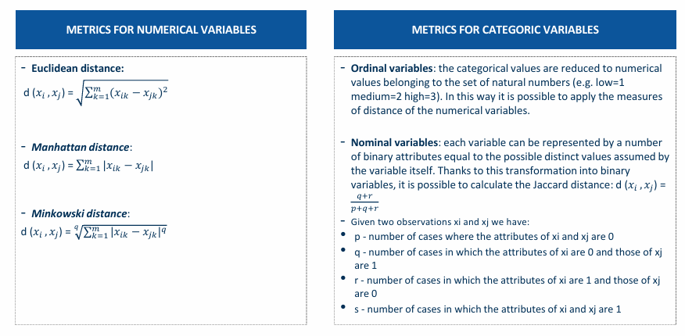

Principal Component Analysis (PCA)
- Simplify the dataset by including only a minimal subset of relevant variables.
- It creates a linear transformation that allows replacing a set of M numerical variables with a smaller subset of K latent variables, without generating of loss of information
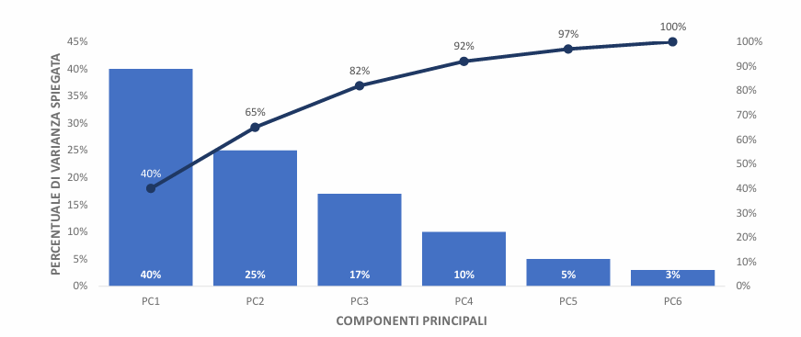

K-means algorithm
Iterative procedure that reallocates the observations within the cluster in order to improve their representativeness.

- Initialization: random choice to constitute the centroids of the initial cluster in the current iteration
- Each observation is assigned to the cluster whose centroid is most similar to the observation
- If no observation is assigned a different cluster than in the previous iteration step the algorithm terminates and converges → THE END
- Otherwise, the new centroid is calculated for each cluster

⟹ K-means algorithm can be strongly influenced by outliers in the dataset 🙁. Risk having a great impact on the average value. It is advisable to proceed first with a data cleaning activity.

Hierarchical methods
- Hierarchical methods overcome the problem of partition methods which require conducting tests and applying a posteriori evaluation methods to identify the solution that best meets business needs to define the number of k clusters a priori.
- Necessary to define a distance between two clusters: average distance, maximum distance between centroids, ward distance

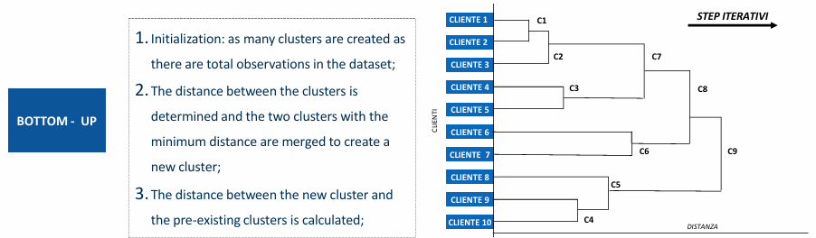
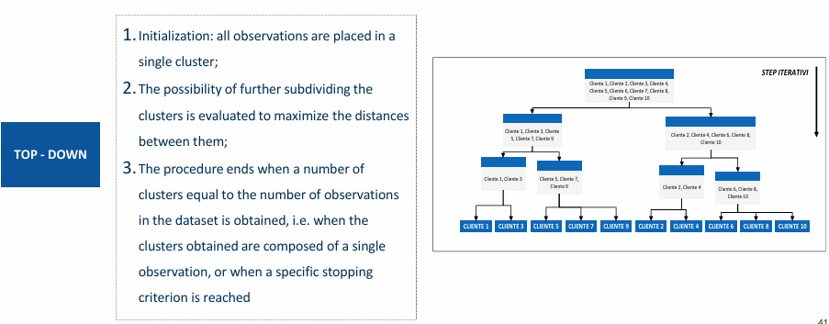

Evaluation by identifying groups of observation that are as similar as possible to each other based on certain predefined characteristics.

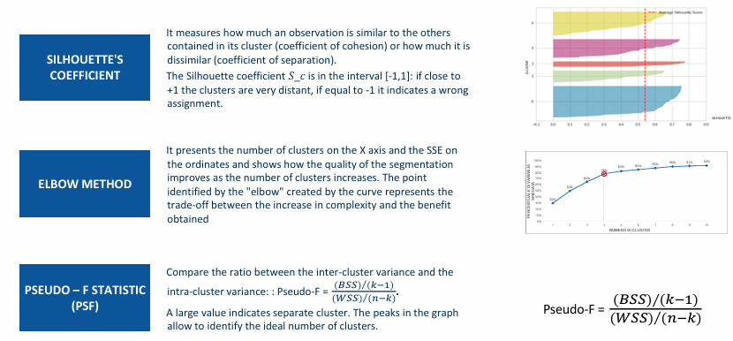



Benefits of behavioral segmentation
- Obtain strategic insights on the customer base to increase loyalty, optimize acquisition, …
- Take advantage of these insights to develop tailor made marketing actions
- Integrate insights into marketing campaign automation
- Understand which is the best acquisition and communication channel for each group
- Compare the percentage distribution of the segments also from a geographical point of view
Limitations of behavioral segmentation
- Difficulty in choosing an optimal set of variables
- Resort to a small number of variables and to standardize them, lose information power
- Use the results of the segmentation by proposing a specific offer to the customers of each group, without applying further filters afterwards in the selection of the target

Lesson 3

Churn and repurchase models: introduction

Churn model
Churn model: customer leaving. Predict which customers are most likely to leave. Focus on repeat customers (more than one purchase) and analyze the main characteristics of those who leave the company.
- Goal: assign to each repeat customer its probability of leaving ⟹ can implement specific corrective marketing actions. A company can plan to activate ad hoc marketing actions depending on the churn risk of customer

Steps:
- Evaluate which type and scenario of leaving you want to deal with
- Identify outlier and evaluate potential exclusions
- Develop exploratory analysis to identify which indicators can be used as substitutes
- Define an analysis perimeter and divide into
  - Observation period (collected data): analysis time which to calculate potential explanatory variables
  - Latency period (tuning time): period to calculate the variables, update the scores, carry out marketing actions
  - Churn period: verify the customer behavior to define the target variable

- Balance the dataset: undersampling, oversampling, synthetic data generation (SMOTE)
- Split train-test
- Metrics: AUC, accuracy, recall

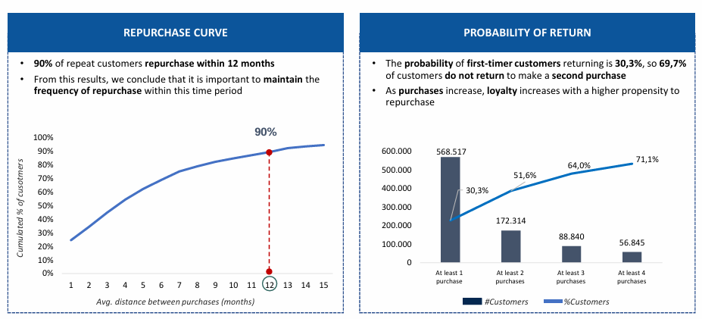

Two different types of test used to test the statistical significance of the variables to be included within the churn model: T-test (numerical variables) and Chi-squared test (categorical variables).

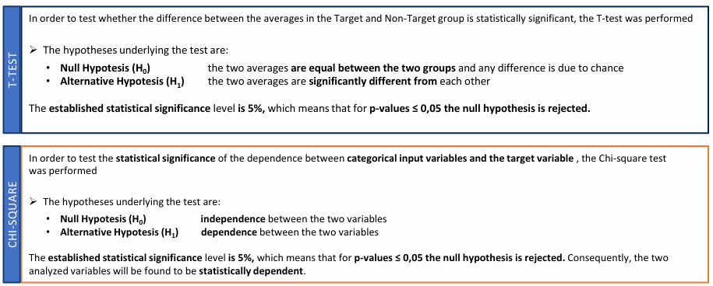
- T-test: the higher the value the greater the probability that the group averages will be statistically different. The p value must be < 0.05
- Chi squared: the higher the value the greater the probability that the independent variable influences the dependent variable. The p value must be < 0.05

Repurchase model
Repurchase model: probability of repurchase by a new customer. Focus on one-shooters (made only one purchase) with the aim of estimating the probability of repurchase.
- Goal: estimated, through a classification algorithm, the probability that, after the first purchase, a customer will buy again ⟹ make it possible to activate new customer through tailor-made marketing actions. It is possible to segment the customer base based on the propensity for a second purchase

Benefits of churn and repurchase model
- Knowing the reason that drive a customer to leaving allows you to implement data driven retention strategies
- The insights generated by the models can be integrated into customer care activities to customize target action on specific customer targets
- The model score can be used to diversity, prioritize and optimize the marketing contact plan. Depending on the risk of customer churn, the probability of repurchasing new customer and their current monetary value

Limitations of churn and repurchase model
- Churn derives from the fact that customer retention initiatives, if effective, alter customer leaving behavior. The data that is used to build the model contains a bias due to the company’s attempts to retain the customer
- The limit of repurchase models are linked to the poorness of available data, since only information about the first and only act of purchase is considered

Lesson 4

Customer Lifetime Value (CLTV)
CLTV: used to analyze the past behavior of customers to estimate the economic value that customers will have in the future relationship with the company.
- CLTV is used to explore the levers on which to act to develop value with the customer, maximizing the profit of the relationship over time

Three different approaches of CLTV
- Traditional approach:
  - CLTV amount, frequency, and duration on relationship CLTV = rt = (mf)t
  - CLTV amount, frequency, duration of the relationship and profit CLTV = rpt = ((mf)p)t
  - CLTV weighted by interest rate and churn CLTV = rpt (1-c) / [(1+i)-1(1-c)]
- Predictive approach (ML):
  - Definition of the time horizon and of the customers whose tenure is ≥ time horizon
  - Creation of model based mainly on socio-demographic and behavioral variables
  - Data quality activities
  - Train-test and cross-validation
  - Evaluation of the ex-post model through linear regression, decision tree, random forest, gradient boosting, neural network
- Predictive approach (econometric models)
  - The distribution curves of some parameters are analyzed in an attempt to construct a probability distribution used as a model for estimating CLTV
  - Among the most used are BTYD (Buy Till You Die) model: based on purchase frequency and churn estimation model

Traditional approach of CLTV
Establish a single time unit which to carry out all metrics (daily, weekly, monthly, …)
Define some variables:
- m: average spending of the customer
- f: average purchase frequency
- t: average duration of the relationship between the customer and the company
- r: revenue of a customer, that is the product of purchase frequency and average amount (r = mf)

CLTV = rt = (mf)*t

- p: company’s profit percentage
CLTV = rtp = (mf)*t*p

- i: discount rate, that is the interest applied to reduce future cash flow, usually around 10% per year
- c: churn rate, that is the percentage of customers who leaving the company in the period
CLTV = rtp * (1-c) / [(1+i)-(1-c)]

Predictive approach Machine Learning
Processing:
- Data exploration: data collection and data preparation and data cleaning
- Model development: significance test for the variables selection, data partition and split train-test
- Business insights: model interpretation and result presentation
- System integration: automation and integration of the best model into company system and into the contact strategy plan

Models:
- Linear regression: supervised learning algorithm that allows you to estimate a quantitative variable based on a linear function
- Decision tree: supervised learning algorithm that divides the dataset into subsets iteratively, choosing the most significant variable in each step and creating one or more subdivision
- Random forest: extend the decision tree concept by building a series of decision tree on different subsets of the dataset
- Neural networks: artificial neurons connected to each other via activation functions

Main evaluation methods:
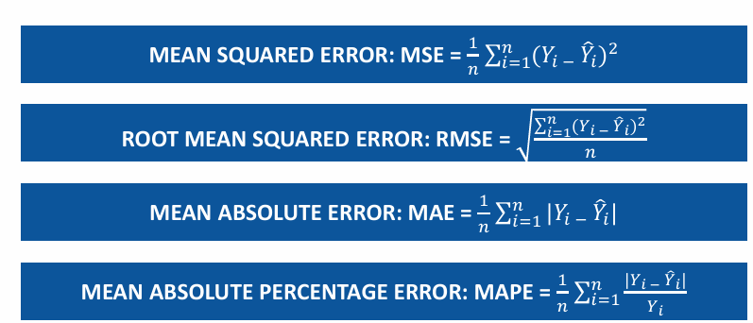

Can use other models developed in the past (churn for repeaters and repurchase for one shooters).

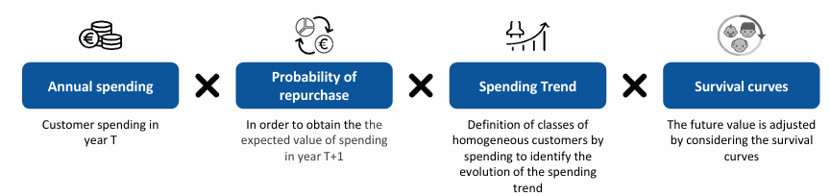

Econometric models
- Buy Till You Die (BTYD) class of models ⟹ simulate customer behavior in a non-contractual scenario when the company is not able to precisely define whether an individual is still a customer or not. BTYD is based on two stochastic processes:
  - Purchase frequency estimation model: simulate purchases made by active customers
  - Churn estimation model: simulate customers who become “inactive”

- Pareto/NBD model: simples version of BTYD model, uses a Pareto distribution for the inactivity process and a Negative Binomial Distribution (NBD) for the buying process
- Βeta-Geometric/NBD: purchasing process is always simulated via a Negative Binomial Distribution (NBD) but the inactivity process is simulated via a geometric distribution with β parameter

Benefits of CLTV model
- Simple and direct way to predict the future value of each customer. It represent a fundamental element within every corporate marketing strategy in the medium and long term
- Guarantees a more in depth knowledge of the customer base and which allows to achieve a concrete result in terms of ROI (Return On Investment), following the development and execution of personalized marketing campaigns on customer with risk of leaving, who represent brand ambassador and with a very high future value is estimated

Limitations of CLTV model
- CLTV calculation is complicated by difficulties in finding historical data with enough depth to allow correct application in the medium to long term
- Difficulty to obtaining immediate indications form the model on which marketing action should be implemented in order to increase the economic value of the customers

Lesson 5

Customer Satisfaction
Goal: listen to customer’s needs and their opinion regarding the company and its offer, identify insights and issues to improve the strategy.
- It costs up to 5 times more to attract a new customer than it does to retain an existing one
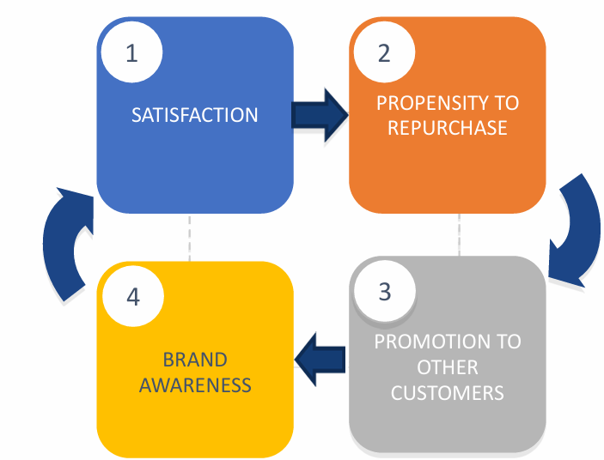

- A satisfied customer is not only more likely to repurchase, but also to recommend to other potential customers the company’s product and services ⟹ increase company’s awareness, reputation and image.

BRS (Brand Recommendation Score) index
- Supporters/promoters: score between 8 and 10. Very loyal customers.
- Neutral: score between 6 and 7. Customers who are on average satisfied but who could switch to a competitor if driven by appropriate marketing actions. No incentive to promote the brand to friends and acquaintances
- Opponents/detractors: score between 0 and 5. Dissatisfied customers who could complain about their negative experience via reviews, social media,...

BRS is calculated by subtracting the % of detractors from the % of promoters. BRS can be -100 (all customers are opponents) and +100 (all customers are promoters)
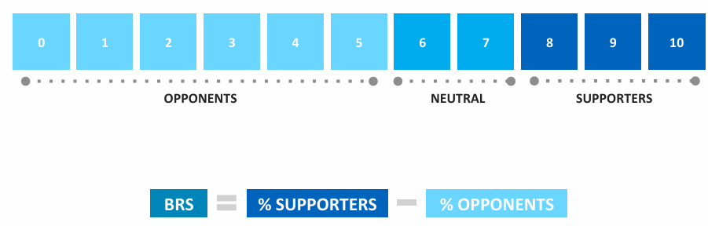
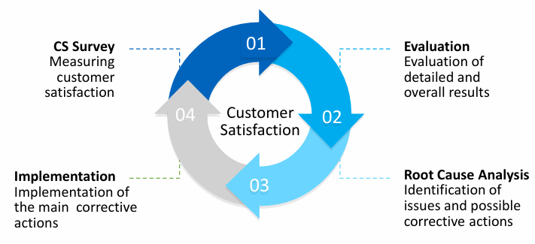

Customer Satisfaction - Traditional approach
- Target definition and extraction
- Areas of analysis
- Computer-Assisted Web Interviewing (CAWI) [interview through an online survey]
- Rating scale/Open ended question
- Periodic monitoring

Linear regression model
- Estimates the values assumed by a dependent variable (overall satisfaction) as a function of a series of other explanatory variables
- It attributes an impact and a direction between the dependent variable (Y) and the other explanatory variables (x)

Forward stepwise
- Begin with no variables (null model)
- Start adding the most significant variables one after the other
- Until a pre-specified stopping rule is reached or until all the variables under consideration are included in the model

Backward stepwise
- Begin with a model that contains all variables under consideration (full model)
- Start removing the least significant variables one after the other
- Until a pre-specified stopping rule is reached or until no variable is left in the model

Customer Satisfaction - Innovative approach
Goal: compute a unique weighted satisfaction score that reflects the customers and emplyee’s perception from multiple points of view including explicit feedbacks, implicit beliefs and socio-economical drivers

The optimized satisfaction index combines four distinct score assigning them unique weights
- Customer satisfaction: score obtained with traditional surveys. Represent explicit beliefs of customers
  - Descriptive analyses to understand how the satisfaction indexes change among different type of clients and demographic groups
- Customer Unconscious satisfaction: score obtained with neuromarketing techniques. Represent unconscious beliefs of customer and employees
- Brand recommendation score: specific surveys and BRS that represents the loyalty of the customers and employees
  - Capture the clients and employees loyalty and their willingness to refer the company to friends, colleagues, commercial partners…
- Net Social Perception Score: sentiment analysis on social data that reflects the perception of the company’s diversity & inclusion approach
  - Sentiment analysis on social media data to capture the clients and employees perception of the company across three spheres:
    - Brand reputation: transparency, data protection, benefits, …
    - Environmental: perception of the company’s digital and carbon footprint
    - Social and D&I: how the company embraces social practices and diversity and inclusion approaches

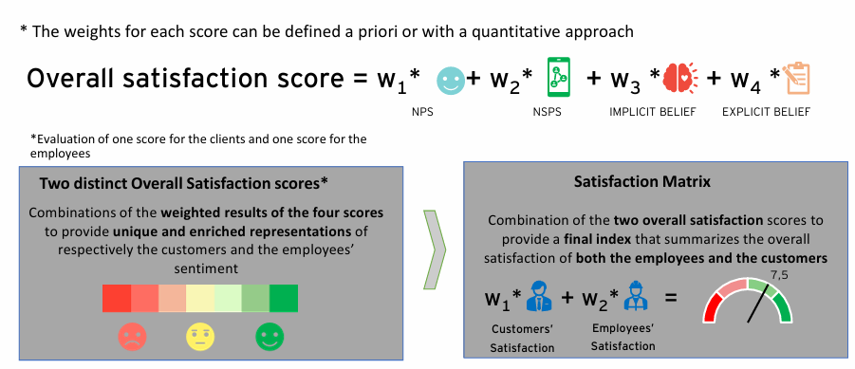

Benefits of Customer Satisfaction
- Simplicity of measurement and interpretation
- Possible to isolate any problems where they arise and to intervene promptly thanks to customer feedback
- More satisfied customer ⟹ more loyal to the company, purchase more frequently, promote products and generate greater revenue for the company
- Can be easily replicated across companies across different industries and therefore can be used as a benchmark metric

Limitations of Customer Satisfaction
- Tendency of customers to be more inclined to complain and remember a negative experience than to provide positive feedback
- Need to measure the reasons for dissatisfaction in real time with traditional methods such as surveys which require greater execution and analysis time

Lesson 6

Neuromarketing & Artificial Intelligence
Goal: determines the communication’s ability to capture attention and be clear and emotionally engaging, both as a whole and in its specific components

Neuromarketing: field of marketing research that studies consumer’s cognitive and affective response to marketing stimuli. By understanding the brain’s response to these stimuli, marketers can craft strategies that are more likely to resonate with consumers. Allow marketers to understand why consumer make the decision they do and what part of the product or advertisement triggers a positive or negative response

- Traditional view: consume make decision based on rational analysis (consider factors like price, quality and utility)
- However most of the decisions we make are a consequence of irrational choices and biases

Brain
- Cortical area: center that make decision that we consciously control → Rational bias
- Subcortical area: center that make decision that we are unconscious → Instinctive bias

- Neuromarketing is based on rigorous scientific knowledge and methods. It involves bioengineers, psychologists, data scientists, marketing experts, …
- Benefits that neuromarketing can bring:
  - Integrates decision-making process through evidence obtained from a deep understanding of the unconscious
  - Reduces errors thanks to the study of consumer’s unconscious
  - Surpasses traditional measurement methods using KPIs based on neuromarketing techniques

Neuroscience-based tool make it possible to measure a range of indicators and obtain information on:
- Visual attention
- Level of attention
- Level of emotion
- Cognitive load

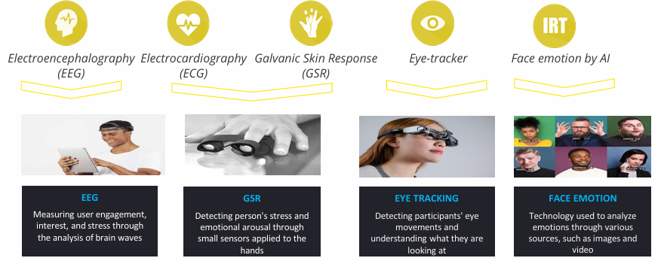

Different types of brain waves
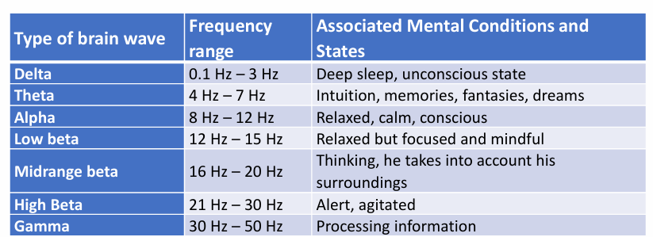

Neuromarketing methodological approach
- Phase 0: definition of an experimental design on a representative sample
- Phase 1: analysis of emotional response while watching videos, images, … Application of AI models to identify the main drivers that generate peaks in cognitive/emotional engagement
  - Application of neuro devices to monitor participants emotional involvement and attention while viewing multiple versions of a communicative stimulus
- Phase 2: analysis of the graphic components to identify the main areas of interest. Application of AI models to identify the impact of graphic components on the use of content
  - Application of behavioral analysis techniques to understand which sections, elements or images have registered the highest level of visual attention. Heatmap, average fixation time, …
- Phase 3: creation of dashboards to enhance the insights generated and speed up the decision-making process
  - Display results and create a ranking of communications for effectiveness. Analysis of the impact of the main drivers present in the communication

Benefits of neuromarketing
- Understand and study the subconscious behavior of customers as they interact spontaneously
- Reliable neurometric indicators through a highly innovative approach and a scientific model
- Capture customer’s instinctive responses free from any cognitive bias and rationalization
- Learn from clients subconscious thoughts and feeling that are otherwise inaccessible
- Improve marketing strategies
- Reduce time between data collection phase and the insights generation process compared to traditional survey or focus group techniques
- Find out which marketing stimuli are most effective in attracting, engaging and motivating a customer to stay loyal to the brand

Limits of neuromarketing
- Criticized the experiment considering them immoral and capable of undermining individual freedom
- Impact on the protection of privacy, potentially undermined by neuroimaging tools that can “read” the human mind
- Fear of technological progress leads to the manipulation of the human mind
- Most vulnerable are children, elderly and people with psychological disorders

Lesson 7

Indigo.AI

Indigo AI: AI platform that uses chatbots and machine learning to automate conversations between business and customers via chat.

Chatbots:
- Understand the user intent
- Delegate to the right assistant
- Retrieve information to answer the request
- Answer the request

2016 vs 2023
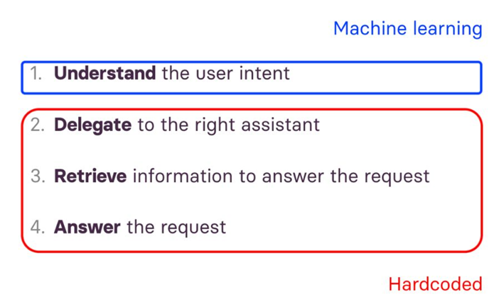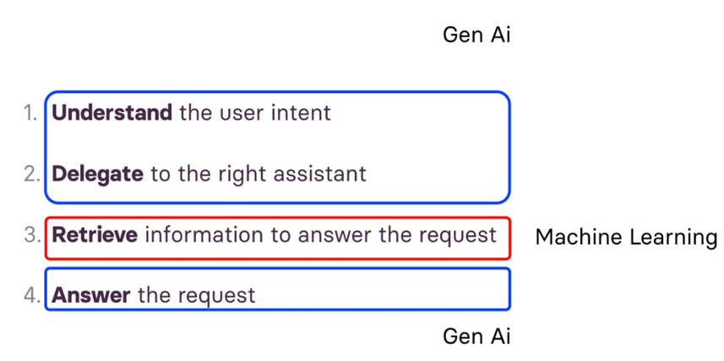

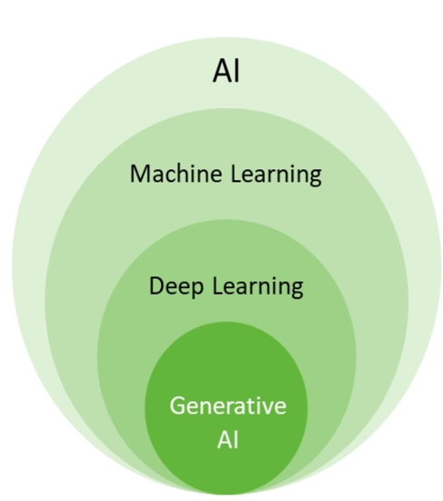
AI: field of computer science focused on creating systems capable of performing tasks that typically require human intelligence
Machine Learning: subset of AI that involves the creation of algorithms that can learn from and make predictions based on data
Deep Learning: subset of ML that uses neural networks with many layers to learn from large amounts of data
Generative AI: type of AI algorithms designed to create new content, ranging from text to images, by learning from existing data

How to model natural language

How do we represent natural language?

Text classification: text is mapped into a space to be used in a ML pipeline (text embedding)
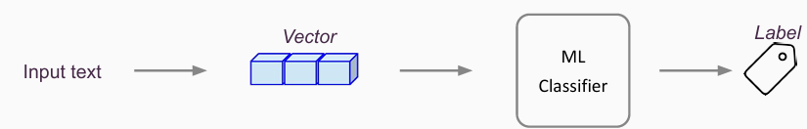

Sparse embedding:
- Easy to obtain
- Curse of dimensionality
- Redundant Features
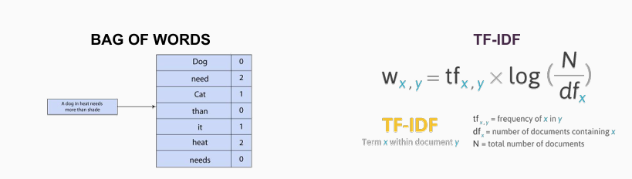

Dense embeddings
Learn dense vector space representation of words (300-dimensional). The space captures the semantic and syntactic relationships.
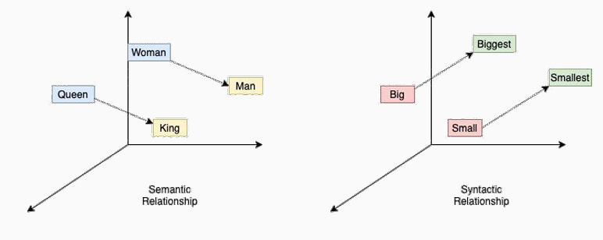

RNN & LSTM
- Have “memory”
- Seeds very suitable for text
- BUT too complex to manage and not parallelizable
- Results not very good 🙁
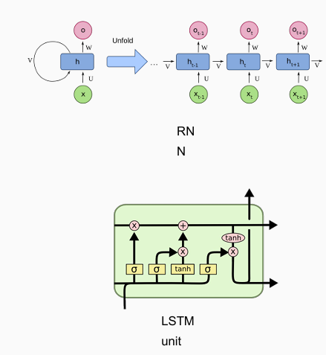

Sentence embedding
- Attention is all you need
- Contextualized text representations obtained without recurrence or convolution
- Parallel computation, not iterative

Transformers and encoders vs decoders
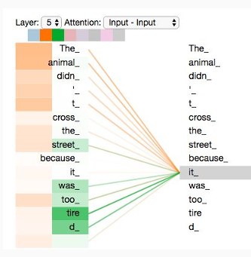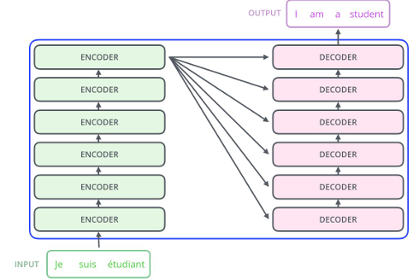

- Encoders: better for representation (classification or embedding)
- Decoders: better for generation

BERT
- Loss → gradient descent → update weights
- Contextual learning
- Bidirectional network (vs causal)
- Pre-train task: masked language modeling

GPT series
GPT-2: one of the first models based on decoders
- Trained of 40GB dataset called webtext
- Objective function: causal language modeling

GPT-3: the first LLM
- 175B parameters
- 300B text token
Concept of emerging abilities has been introduced: new abilities not present in the smaller models, which have emerged from the scaling of these models



Pre-training: model is trained on a big corpus on a self-supervised objective (usually MLM) to learn generic knowledge of the language
Fine-tuning: model is fine-tuned on a small task-specific corpus

From GPT-3 to ChatGPT
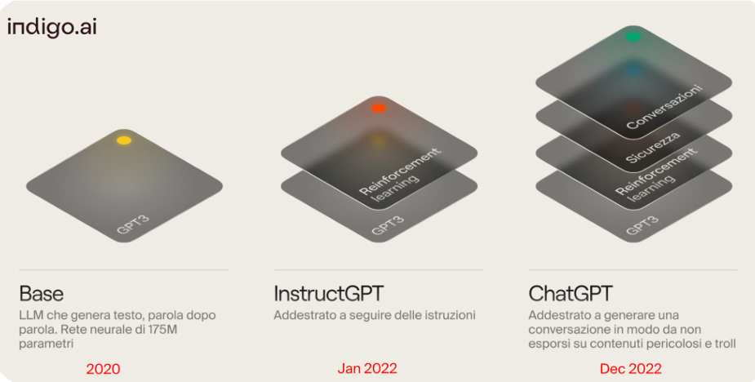

Reinforcement learning (RL): a type of AI where a computer program learns to make decisions by trying different actions, receiving feedback in the form of rewards or penalties, and adjusting its actions accordingly to maximize long-term success.

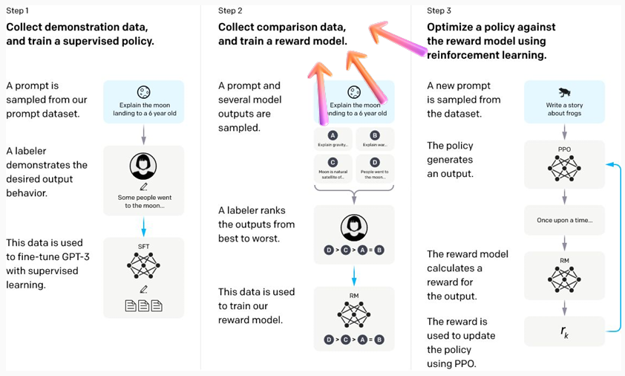

Emerging Abilities
- How small changes to a system can lead to drastic changes in behavior
- An ability is emergent if it is not present in smaller models but shows up in larger models

Prompting
How models followed the instructions given to them. Process of creating and optimizing the text messages to be given to LLMs to achieve the desired results

From models to data
- Attention of researchers and experts has shifted from advancing models to improving the quality and quantity of data
- When the model becomes powerful enough we just need to tune the prompt, without having to change the model

How to find the optimal prompt
- Create efficient prompts because AI is very sensitive to the words used

Challenges with prompt engineering
Hallucinations: text that is factually incorrect or nonsensical, but very likely

How to deal with hallucinations
- Method 1 hypercontrol: use prompt chaining to check or fix a generation
- Method 2 tooling: chatbot access external information, like calling APIs and can integrate the right information into the prompt
- Method 3 agents: like human LLMs have better performances if specialized and orchestrated by a central “brain”

Impact on society
- Provisional limitation of the processing of data of Italian users by OpenAI
- Irregularities found in the use of user’s personal data by OpenAI
- Data are essential to train the algorithms underlying the operation of the platform
- From a technical point of view, the procedure required by the guarantor is somewhat complicated

- Generations: not including citations or IP address of the material used → is it plagiarism ⟹ no, new textual generations
- Generations LLMs protected by copyright: copyright = human authorship

Closed AI
- GPT 4 is 82% more likely that GPT3.5 not to respond to request for content that OpenAI does not allow
- GPT4 is 60% less likely than GPT3.5 to have hallucinations
But OpenAI does not provide the metrics to verify this

Possible solution directions
- Reduce the asymmetries between the private sector and academia
- Model red teaming: develop ways to explore model inputs and outputs to predict damage before deployment
- Government structures and government interventions
- Improve the tools available for model evaluation
- Improve our understanding of abrupt abilities

Lesson 8
Same of lesson 6

Lesson 9
QVC

Propensity models in the customer lifecycle
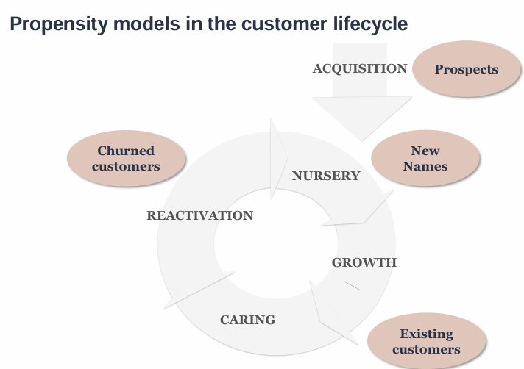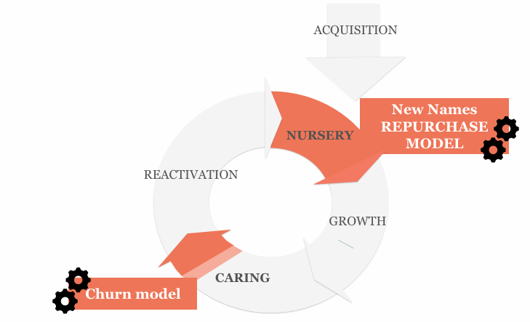

Propensity model: use when we need to have smaller and better targets, than random selection in order to:
- Avoid spam
- Respect contact rules
- Save money: promotional offers
- Save money: channels costs (paper direct mail and output telephone call can be expensive)
- Save operational costs on bad responders
- Show the vendor a higher redemption rate

New Name repurchase propensity model
Goal: assign to each New Name a probability of repurchase based on the behavior of NNs in the past ⟹ enrich the profile of QVC New Names, identify who has a higher propensity towards a second order, identify and ensure priorities based on the probability of repurchase,

Model development & methodology
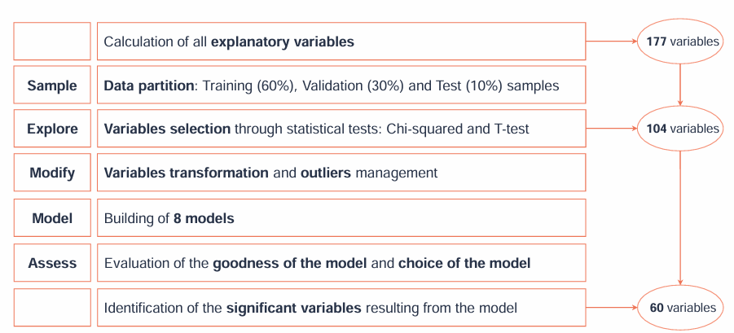

Models
- Decision tree: identify the set of rules that better distinguish between the target 1/0
  - Example: we want to associate the probability of purchasing a certain brand. In total the population we have 15% target = 1.
    - First rule involves age: target = 1 is 25% among customers age 20-30
    - Second rule involve gender: target = 1 if 16% among females
    - …
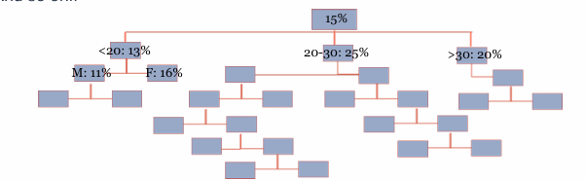

- Random forest: ensemble learning method that operates by constructing a multitude of decision trees and outputting the class that is the average prediction of the individual trees.

2023 NN retention campaigns
- Offer different voucher depending on the propensity assigned by the model
- Every month the redemption of targets is greater than the control groups one. The average redemption rate is 1.2%
- The campaigns with the higher redemption rate are the ones towards NN with high propensity to purchase conforming the propensity assigned by the model, the redemption rate is 1.8% each month regardless of the assigned voucher
- +79% incremental revenue generated in 2023 vs 2022 by NN retention voucher campaigns

Churn Propensity Model
cose classiche

Lesson 10

Algorithms for association rules (product association analysis) - Market Basket Analysis (MBA)
Goal: identify association rules between items that appear jointly in an event, identifying patterns of products/categories that are most likely to be purchased ⟹ used in promotional mechanism for specific targets and create personalized marketing campaigns based on customer’s purchase history

Market Basket Analysis (MBA): allows the identification of so-called driving products/categories. MBA can be integrated into marketing automation to enrich the contact strategy through the next best product to buy based on the correlation between driving and driven products.
- The model recognizes in advance unknown purchasing patterns according to customer’s behavior

Associative rule: implication between two propositions of the type {X} ⟹ {Y} such that if {X} is true then {Y} is also true.

MBA consists in analyzing the transaction made by customers to understand their purchase pattern by finding association between the different products that the customer places in the cart.

Methodological approach related to the association rule
- Dataset D of n observations, each of which made up of m binary variables indicating the presence or absence of object m within the single observation
- Define an associative rule as implication X ⟹ Y
- X (antecedent of the rule) and Y (consequent) of the rule
- Define a support of the associative rule

{pencil, paper} ⟹ {rubber}

Support: the percentage of transactions that contain all of the items in an itemset (e.g., pencil, paper and rubber). The higher the support the more frequently the itemset occurs. Rules with a high support are preferred since they are likely to be applicable to a large number of future transactions.

Confidence: the probability that a transaction that contains the items on the left hand side of the rule (in our example, pencil and paper) also contains the item on the right hand side (rubber). The higher the confidence, the greater the likelihood that the item on the right hand side will be purchased or, in other words, the greater the return rate you can expect for a given rule.

Lift: the probability of all of the items in a rule occurring together (otherwise known as the support) divided by the product of the probabilities of the items on the left and right hand side occurring as if there was no association between them. For example, if pencil, paper and rubber occurred together in 2.5% of all transactions, pencil and paper in 10% of transactions and rubber in 8% of transactions, then the lift would be: 0.025/(0.1*0.08) = 3.125. A lift of more than 1 suggests that the presence of pencil and paper increases the probability that a rubber will also occur in the transaction. Overall, lift summarizes the strength of association between the products on the left and right hand side of the rule; the larger the lift the greater the link between the two products.

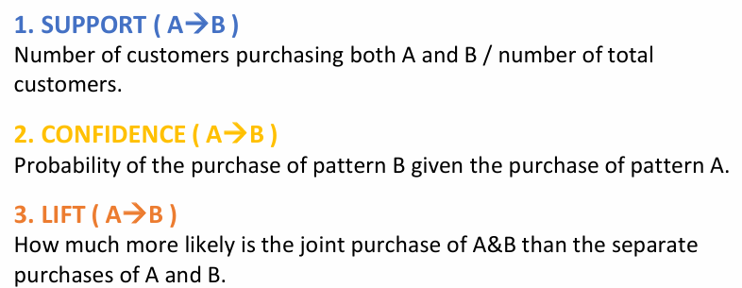

We choose a minimum supporting value and a minimum confidence value and we do a search for the rules that exceed these criteria, called strong association rules.

Rule with the highest confidence
Advantages
- The cluster already intercepts purchasing behavior similarities
- It will increase the probability to find available product to offer to the customer, even if less personalized
Disadvantages
- The cluster rule with highest confidence could be very different from the single customer’s purchasing habits
- It is a less personalized choice, that could lead to lower redemption

Product propensity model
Goal: identify undecided customers, those with the lowest probability of purchasing a certain product or service and on which to carry out specific marketing activities to convince them to purchase a particular product or product category.
- Allow to identify the probability that a customer will purchase a specific product, product category or service
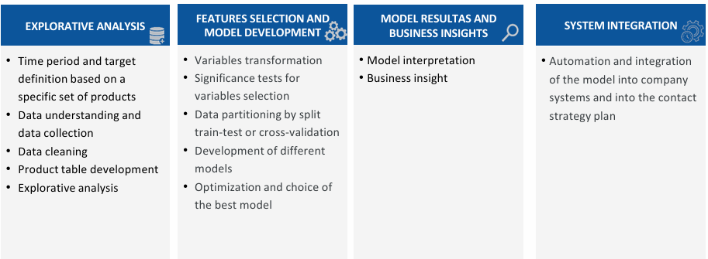

Next Basket prediction by RNN
- RNN: interconnected nodes or units arranged in a chain-like structure. Each unit receives inputs from its predecessor, processes the information and generates an output that is passed on the next unit. The recurrent connection allows the NN to capture long-range dependencies in the input data.

- If we have a long enough sequence of customer’s purchases we can estimate the probability of each product to be present in the next purchase.
- For a better accuracy we can integrate with some customer data and socio-demographic information

Benefits of Market Basket Analysis
- Observe, study and justify the correlations that lead to the purchase of certain baskets of good, conditional on the previous purchase of others
- Define measure and monitor campaigns over time to increase both cross-selling and up-selling
- A priori evaluate the introduction of new product on the market
- Design the best possible arrangement of the product on the shelf

Limitations of Market Basket Analysis
- Fresh product like fruit and vegetables can not be return if the model has incorrectly predicted their need by the customer
- Some research argue that existing RNNs are unable to directly capture item frequency information in the recommendation scenario as they do not take into account the frequency of personalized items

Lesson 11

Measurement of marketing communications (marketing communication optimization)
Goal: understand the impact of each marketing activity on brand perception, incremental sales and customer base growth is crucial for the proper allocation, management and planning of the company budget
- If a company operates on multiple channels, it can be useful to have a precise metric that indicates not only how the strategy is performing, but also which channel is most effective.
- Monitoring the results of individual marketing activities is crucial for any company as it allows for timely problem-solving.

Main methodological approaches for measuring marketing activities are
- Main metrics for measurement of marketing activities: cost per sale, return of investment, control-group, A/B testing
- Attribution models: methodologies that allow the results of marketing activities to be attributed to specific touchpoints with the customer, to identify which of these have had the greatest influence on the purchase path. Use the results of attribution models to understand which touchpoints have had the most influence on buyers journeys.
- Marketing Mix Models (MMM): these models are fundamental for quantifying the impact of each marketing activity for each communication channel on sales compared to the investments made, for the optimization of marketing activities, improving effectiveness in terms of Return On Investment (ROI).

Essential for the company to monitor the changes in its revenues considering:
- Return On Investment (ROI): every marketing campaign is an investment for the company. The ultimate goal of the company must be to achieve a positive ROI (aka covering the investment expenses). It is essential to measure the amount of incremental sales each campaign has generated
- Cost per sale: if a Google AdWords campaign costs 10.000€ and only five customers were acquired, each with an average spend of 200€ the company must consider the overall margin of these sales
- Cost per lead: monitor the cost of each conversion from user to potential customer. The marketing team might be able to attract numerous high-quality leads, but if the cost of this operation is particularly high, it may not be beneficial for the company
- Conversion rate: ratio between those who fill out the contact form and those who enter the company’s online platform and make a purchase.
- Brand awareness or “brand recognition”: process of acquiring identity and distinctive features that set the company apart from its competitors.
- Number of followers on social networks: people who know and appreciate the brand, even if they do not necessarily purchase the products regularly. The higher the volume of mentions the greater the likelihood of having achieved business objectives.
- Control group: as a benchmark for a specific target campaign
- A/B testing approach: evaluating, for example, the effectiveness of two versions of marketing campaigns in terms of creativity

Main metrics for measurement of marketing activities

Target and control group definition
- Customers similar to each other whose behavior is observed in the same conditions as the target without receiving the marketing action. The two groups are homogenous.
- The study of differences in behavior reveals insights into the effectiveness of marketing activity

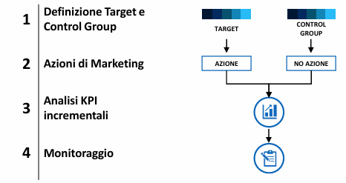
After defining the target of the marketing campaign we marketing actions by sending communication by different channels. Then we do analysis of the main KPI and so we calculate the main metrics such as the incremental turnover or the conversion rate of the target compared to the control group. Lastly the identified KPIs are monitored over time, so as to be able to intervene quickly if the campaign is not effective.

Example comparing the conversion rate between the target group and the control group. The differences in terms of conversion between the two groups is attributable to the marketing action and not to chance.
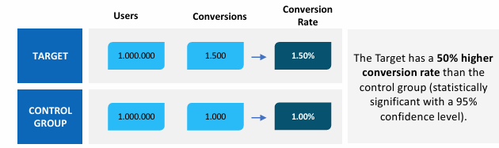

A/B testing
- Is the best known and most used methodology to verify the effectiveness of a specific marketing initiative.
- In A/B testing both samples (A and B) receive marketing action (but different from each other). We verify which of the two variants is more effective.
- Then analyze the main KPIs and verify the significance from a statistical point of view.
- A/B testing often applied to graphic elements and creativity (images, texts, colors) as well as information texts, various promotion offers and calls-to-action presented to users.

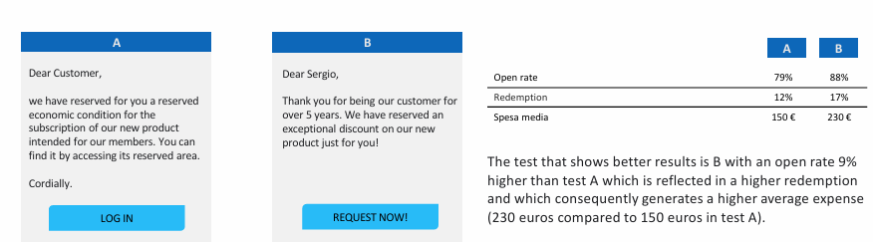

Attribution Model
Attribution models allow to measure the value of campaigns and understand which touchpoints have the greatest influence on the conversion journey in terms of
- Maximization of volumes
- Most budget efficient spending

Key concepts
- Conversion: desired results/goal from the web or store
- Conversion value: total cost of the action taken by the company
- Touchpoints: touchpoints that the customer experiences in the purchasing process
- Contributions: the different moments that contribute to a purchasing decision

It is important to understand the influence of the key characteristics of the path such as
- Length of user path: number of touchpoints
- Information recency: location of touchpoints along the user journey (relative to the point of conversion)
- Touchpoint granularity

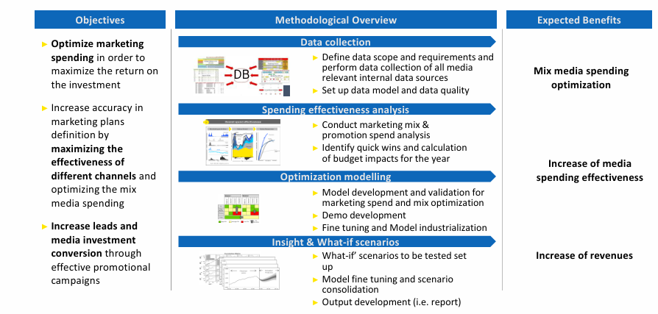

Markov model
- Probabilistic model that represents customer journeys as a graph whose nodes are the touchpoints or “layers” and the connecting edges are the observed transitions between the layers
- Thanks to this mode is possible to
  - Obtain the probability of success of a given customer journey given the history of all customer journeys
  - Gauge the importance of each campaign by calculating what is known as the takedown effect

Shapley value:
- Aims to fairly allocate each touchpoint contribution to the conversion through the following rules:
  - Marginal contribution
  - Interchangeable layers have the same value
  - Fictitious players have zero value
  - If a game has multiple parts, the cost must be broken down between those parts
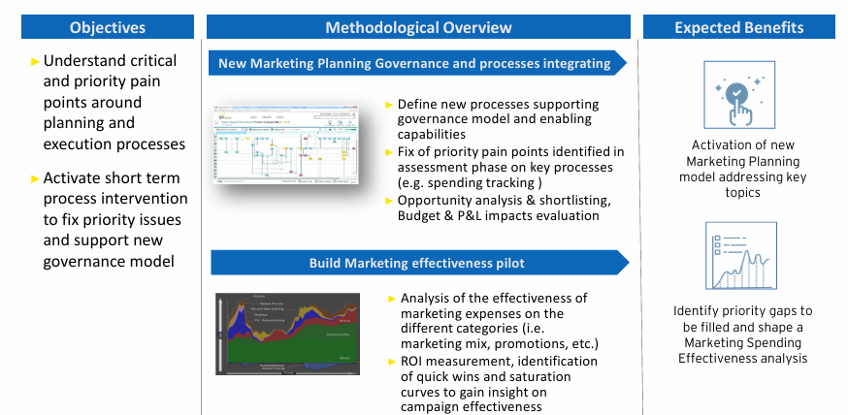

Marketing Mix Model (MMM)
MMM provides an ROI (Return On Investment) measurement for every investment you make. It identifies the most effective combinations of media channels and allows you to develop an organic strategy for each communication channel that maximizes the economic return compared to the invested budget. MMM also create awareness and positioning.

MMM is a statistical model built to be able to measure the effectiveness of communication spending using historical data in aggregate form, with the aim of analyzing sales trends in the time, according to advertising spending variables and in the various marketing channels.

Data is collected and grouped by variables
- Target: concern sales, divided according to sales channels
- Independent, divided in:
  - Average metric: average investments, impressions, clicks, …
  - Marketing: calendar of promotions or discounts, historical price trend per product
  - Control: seasonality, weather forecast competition, brand awareness, …

The general statistical representation of the MMM is represented as a linear regression model: Y = α + β_{i}X_{i} + ε_{i}

Linear regression model
Linear regression models: consider sales or the number of contracts signed as the dependent variable and all marketing activities and other external control factors among the independent variables.
A linear regression model is represented by the following formula

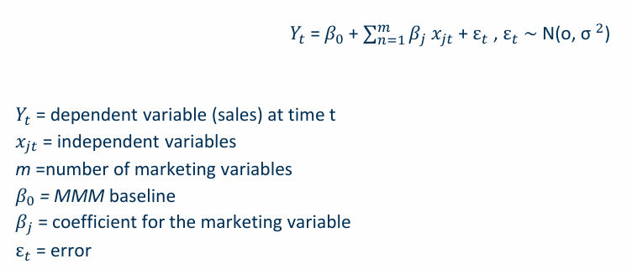


A linear regression model is an adequate model for a company with a stationary product, operating in a mature market, with moderate seasonality and made up of several competitors, in which it is assumed that each mic level contributes to generating volumes independently of the others

Multiplicative regression model
Multiplicative regression model: consider a multiplicative relationship between the independent variables of the MMM. It describes the effect of m possible variables on sales. It is represented by the formula
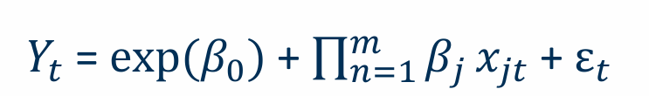


- The logarithmic transformation of the target variable linearized the model, making it possible to estimate as a simple additive model.

Benefits of multiplicative regression model:
- The dependent variable undergoes the effect of the interaction of all the marketing variables considered
- Model more flexible and better to estimate relationships
- The coefficient both estimate the effects of the independent variable on the dependent variable and they also represent a sales elasticity value with respect to advertising

What if scenario?
Create scenario where we shift 5%, 10% or 15% of the budget from one channel to another (radio→tv)

Main results
- ROI estimation and evaluation of campaign performance for individual investment channels
- 2% increase in the number of incremental acquisitions through “what if” scenario by shifting budget from a channel to another
- Identification of most profitable media channels and optimization of Next Campagin’s Media Investment Effectiveness

The interaction of all models allows the creation of a data driven customer journey
